**Working with ETCDCTL**

etcdctl is a command line client for **[etcd](https://github.com/coreos/etcd" \t "_blank)**.

In all our Kubernetes Hands-on labs, the ETCD key-value database is deployed as a static pod on the master. The version used is v3.

To make use of etcdctl for tasks such as back up and restore, make sure that you set the ETCDCTL\_API to 3.

You can do this by exporting the variable ETCDCTL\_API prior to using the etcdctl client. This can be done as follows:

export ETCDCTL\_API=3

On the **Master Node**:

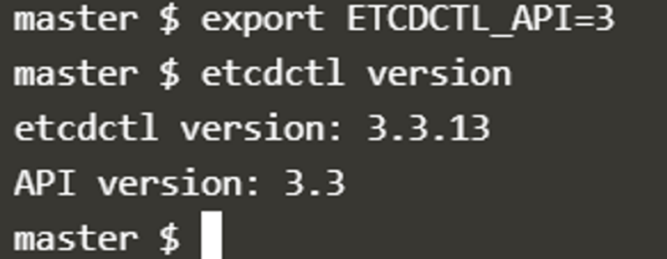

To see all the options for a specific sub-command, make use of the**-h or --help** flag.

For example, if you want to take a snapshot of etcd, use:

etcdctl snapshot save -h and keep a note of the mandatory global options.

Since our ETCD database is TLS-Enabled, the following options are mandatory:

--cacert                                                verify certificates of TLS-enabled secure servers using this CA bundle

--cert                                                    identify secure client using this TLS certificate file

--endpoints=[127.0.0.1:2379]          This is the default as ETCD is running on master node and exposed on localhost 2379.

--key                                                      identify secure client using this TLS key file

Similarly use the help option for **snapshot restore**to see all available options for restoring the backup.

etcdctl snapshot restore -h

For a detailed explanation on how to make use of the etcdctl command line tool and work with the -h flags, check out the solution video for the Backup and Restore Lab.

<https://kubernetes.io/docs/tasks/administer-cluster/configure-upgrade-etcd/#backing-up-an-etcd-cluster>

<https://github.com/etcd-io/website/blob/main/content/en/docs/v3.5/op-guide/recovery.md>

<https://www.youtube.com/watch?v=qRPNuT080Hk>